LITERATURE SURVEY

**Project Title :** DemandEst - AI powered Food Demand Forecaster

**Team Leader** :Priyadharsan S

**Team Member 1** :Balamanikandan S **Team Member 2** :Harishbabu P

**Team Member 3** :Keerthi vasan B

**Team Member 4 :** Kevin C

PROJECT DESCRIPTION

* A food delivery company has to deal with a lot of perishable raw materials. Thus it is very important for such a company to accurately forecast daily and weekly demand. We have seen the problem of unbalanced demand and supply in food delivery industry. We always wanted to solve this problem, so this our chance to represent our idea and solution.

WHAT IT DOES

* We created website using an appropriate machine learning model, to forecast number of orders to gather raw materials for next few weeks. The prediction model is a generalized model which means other companies or services can rebuild this model according to their data. In the web application, a separate section called ‘inventory management’ is for restaurants where they can log in/sign up and can keep record of available inventory and also manage their customers and orders.

EXISTING MODEL

* LONDON--[(BUSINESS WIRE)](https://www.businesswire.com/)--Infiniti Research, a market intelligence solutions provider, has recently announced the [completion of their latest](https://cts.businesswire.com/ct/CT?id=smartlink&url=https%3A%2F%2Fwww.infinitiresearch.com%2Fcasestudy%2Ffood-manufacturing-industry-demand-forecasting%3Futm_source%3DCSWeek25%26utm_medium%3DbusinesswireWeek25%26utm_campaign%3DbusinesswireCSWeek25&esheet=52003231&newsitemid=20190621005297&lan=en-US&anchor=demand+forecasting+solution+for+a+food+manufacturing+company&index=1&md5=f612ec82ff531944b9c622783f4c2293) [**demand forecasting solution for a food manufacturing company**. During the course of this](https://cts.businesswire.com/ct/CT?id=smartlink&url=https%3A%2F%2Fwww.infinitiresearch.com%2Fcasestudy%2Ffood-manufacturing-industry-demand-forecasting%3Futm_source%3DCSWeek25%26utm_medium%3DbusinesswireWeek25%26utm_campaign%3DbusinesswireCSWeek25&esheet=52003231&newsitemid=20190621005297&lan=en-US&anchor=demand+forecasting+solution+for+a+food+manufacturing+company&index=1&md5=f612ec82ff531944b9c622783f4c2293) engagement, the experts at Infiniti Research helped the client to efficiently meet the market demand by keeping adequate stocks. Also, the study highlights how Infiniti’s demand forecasting solution helped the food manufacturing company to increase supply chain efficiency, improve labor management, and manage cash flow better.

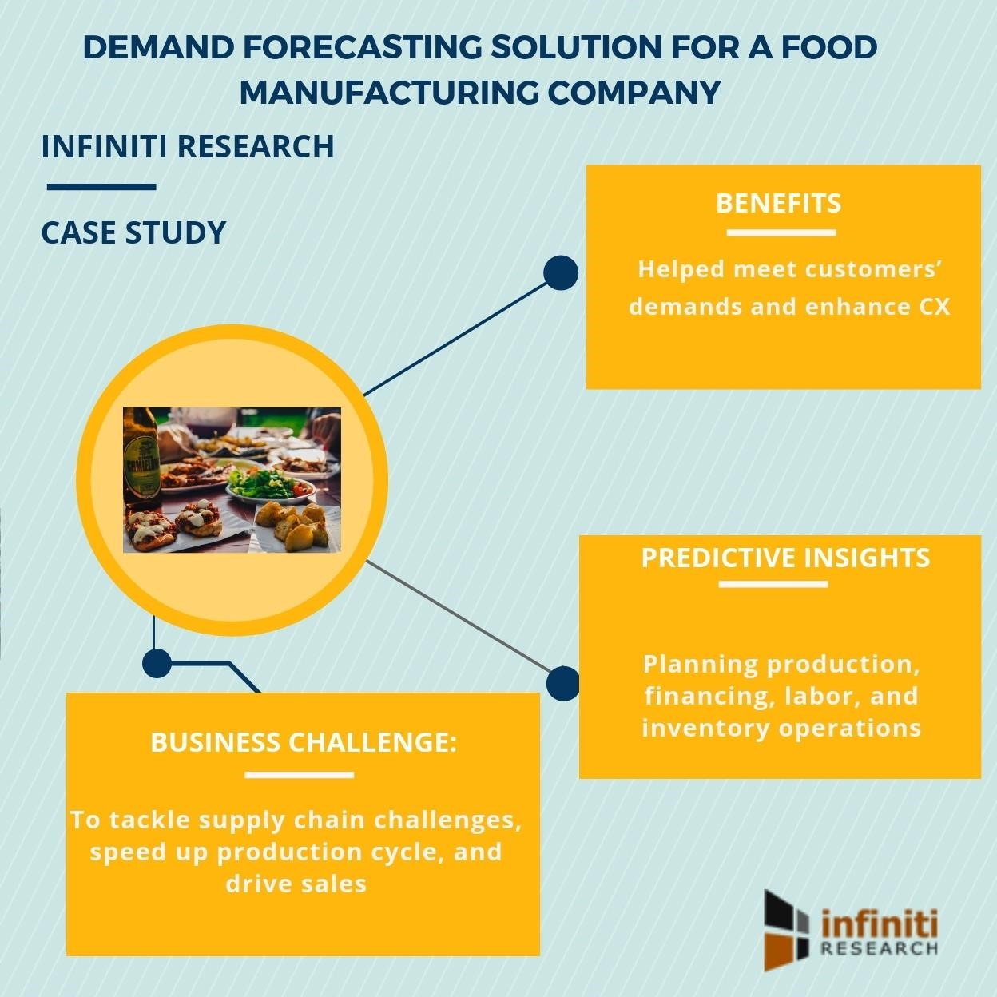

THE BUISNESS CHALLENGE

* The client is a food manufacturing company based out of the United States. The client constantly faced issues of stock-outs. With this, they had to deal with unplanned production changeovers to keep up with the business. The client was also having difficulties in managing labor and planning inventory operations. Owing to these challenges, the company witnessed a dip in their sales rate. Therefore, the client approached Infiniti Research to leverage their expertise in offering demand forecasting solution. With Infiniti’s demand forecasting solution, the food manufacturing company wanted to tackle supply chain challenges, speed up production cycle, and drive sales.

THE EXISTING SOLUTION

* The experts at Infiniti Research conducted qualitative and quantitative market research, analyzed client’s sales data for the past 5 years, and also analyzed competitors in the US food manufacturing industry. With Infiniti’s demand forecasting solution, the client was able to accurately forecast the sales demand and manage inventory. This reduced stock-outs of products. This further helped them in better labor management. Also, with Infiniti’s demand forecasting solution, the client was able to better manage warehouse and cash flows.

ADVANTAGES

* 1. You’ll gain valuable insight
  2. You’ll learn from past mistakes
  3. It can decrease costs

DISADVANTAGES

* 1. 1. Forecasts are never 100% accurate
  2. It can be time-consuming and resource-intensive
  3. It can also be costly

CONCLUSION

* The main moto behind this project is to reduce food wastage. The availability of the food items makes the society better. Our proposed model would definitely come handy to a company for predicting the number of food orders and help them to serve their customers better.

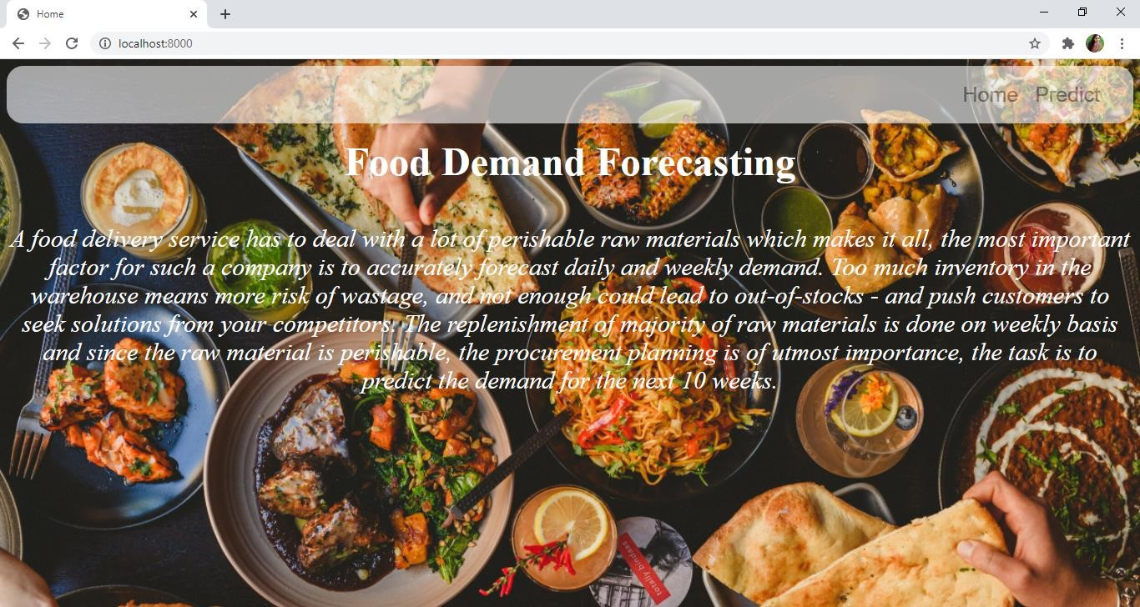**THE PREDICTED OUTPUTS**

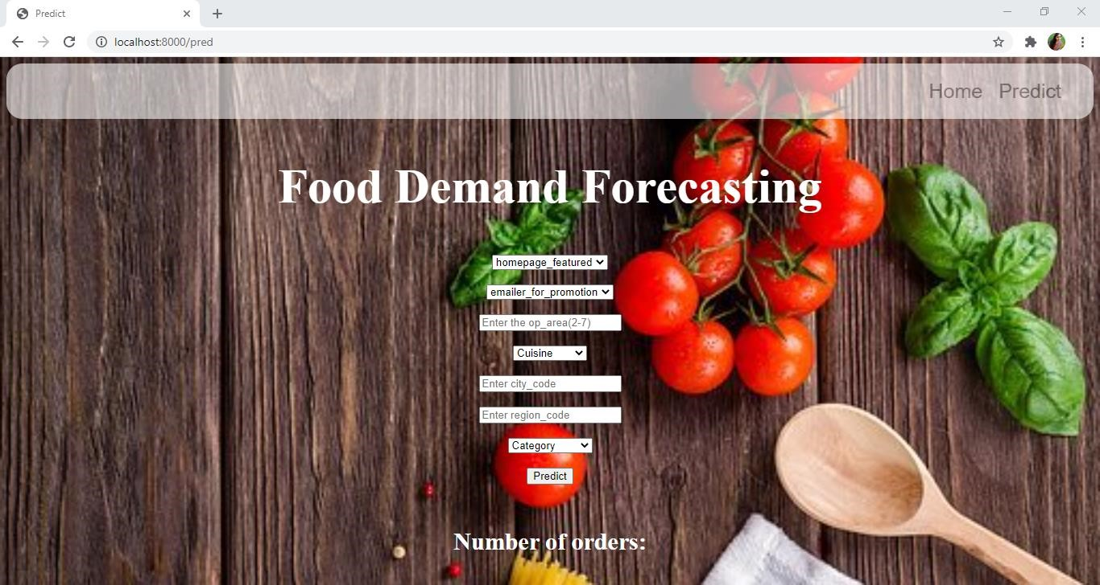

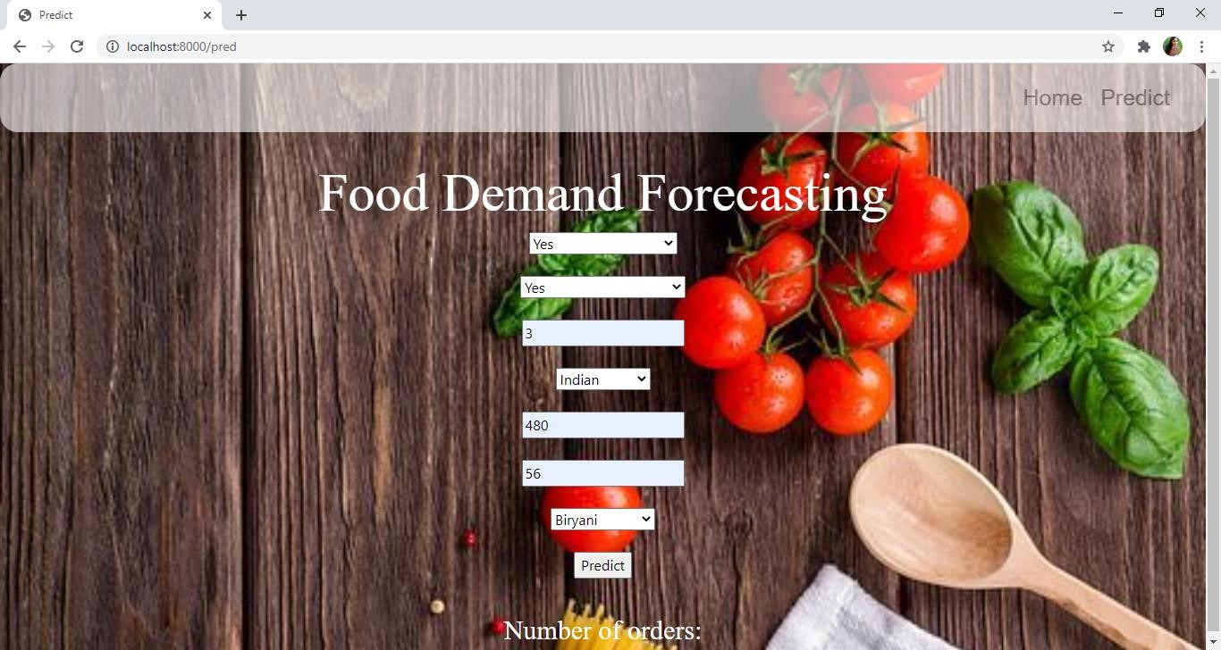

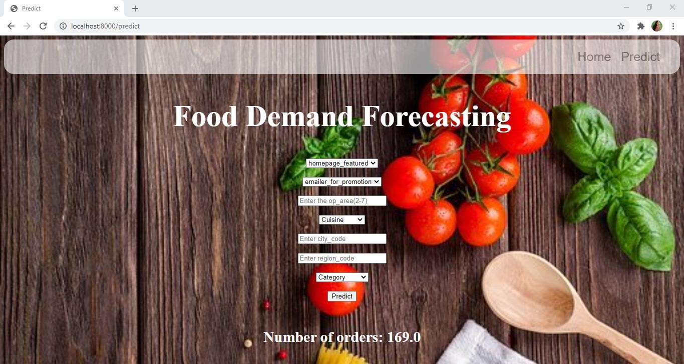

THANKYOU !